* **Name – Vinay Nitin Sarda**
* **Exp-7**
* **Roll No. – 23**
* **Class – S.Y.B.tech(B)**
* **Batch – B2**

**Problem Statement –**

Operate file using DataOutputStream , DataInputStream, FileInputStream,

FileOutputStream.

**Program –**

import java.io.*;

import java.util.Scanner;

public class FIS_FOS_DIS_DOS {

public static void main(String[] args) throws IOException

{

Scanner sc = new Scanner(System.in);

System.out.print("Enter File Name : ");

String f_name= sc.nextLine();

File f= new File(f_name);

if(!f.exists())

{

f.createNewFile();

}

FileOutputStream fout=new FileOutputStream(f,true);

System.out.println("Please enter data to write on file : ");

String str=sc.nextLine();

fout.write(str.getBytes());

DataOutputStream out= new DataOutputStream(fout);

out.writeInt(70);

out.flush();

out.close();

fout.close();

FileInputStream fin =new FileInputStream(f);

DataInputStream din= new DataInputStream(fin);

int count=fin.available();

byte[] bdata =new byte [count];

din.read(bdata);

for(byte b: bdata)

{

System.out.print((char)b);

}

din.close();

fin.close();

}

**Output –**

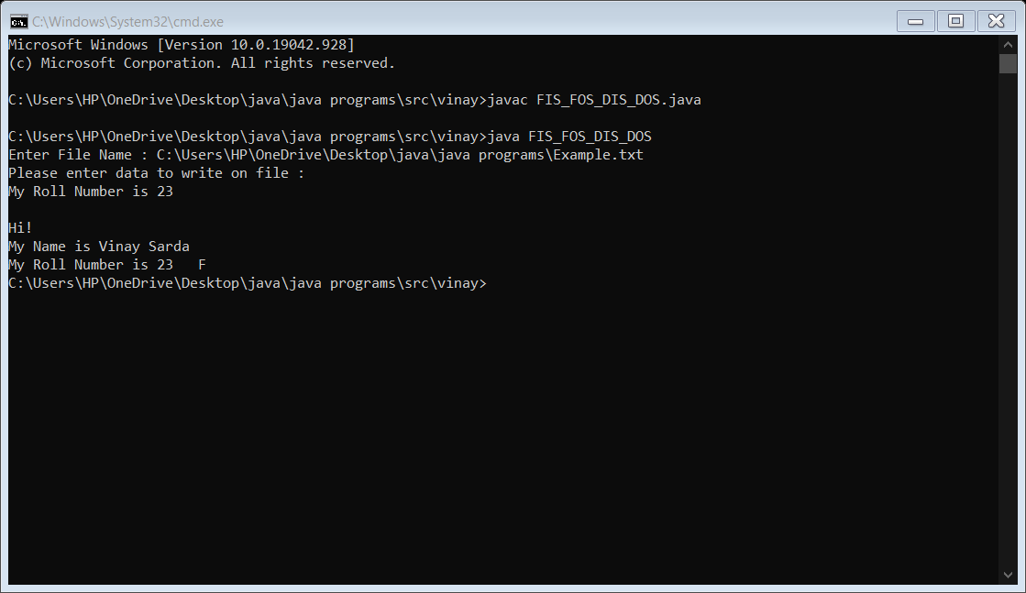

**File content –**

Hi!

My Name is Vinay Sarda

My Roll Number is 23 F